PROJECT REPORT
Auto Sage App Using Gemini Flash

++

1. INTRODUCTION
1.1 Project Overview
AutoSage is an AI-powered smart assistant web application built using Google Gemini Flash (Generative AI). The application enables users to interact with advanced AI capabilities such as intelligent question answering, content generation, summarization, and contextual responses in real-time.
The system is designed to provide fast, lightweight, and cost-efficient AI responses using the Gemini Flash model. AutoSage focuses on productivity enhancement, learning assistance, and automation of text-based tasks.

1.2 Purpose
The purpose of AutoSage is to:
- Provide a user-friendly AI assistant platform.
- Utilize Gemini Flash for high-speed AI inference.
- Help users generate content, summaries, code, and answers instantly.
- Demonstrate practical implementation of Generative AI using Google Cloud.

2. IDEATION PHASE
2.1 Problem Statement
Many users require intelligent assistance for tasks such as content writing, coding help, summarization, and research. However:
- Existing AI tools may be complex or expensive.
- Integration of generative AI into custom apps is often difficult.
- Users need a simple, fast, and interactive AI tool.
AutoSage solves this by providing a streamlined AI-powered web application using Gemini Flash.

2.2 Empathy Map Canvas
Users:
- Students
- Developers
- Content creators
- Professionals
User Needs:
- Quick and accurate responses
- Simple UI
- Cost-efficient AI usage
- Multi-purpose assistant
User Pain Points:
- Slow AI responses
- Complicated interfaces
- API configuration errors
- High usage cost
User Gains:
- Time-saving
- Productivity boost
- Instant code/content generation
- Learning assistance

2.3 Brainstorming
Possible solutions discussed:
- Integrating Gemini Flash API with Streamlit
- Adding conversation history
- Implementing prompt customization
- Error handling for API key validation
- Deploying app on cloud platform
Final Idea:
Develop a lightweight AI assistant using Gemini Flash integrated with Streamlit.

3. REQUIREMENT ANALYSIS
3.1 Customer Journey Map
- User opens AutoSage web app.
- User enters query or prompt.
- Application sends request to Gemini Flash API.
- AI generates response.
- Response displayed instantly.
- User refines prompt or continues conversation.

3.2 Solution Requirement
Functional Requirements:
- User input text field
- API integration with Gemini Flash
- Real-time response display
- Error handling for invalid API keys
- Clear chat interface
Non-Functional Requirements:
- Fast response time
- Secure API key handling
- Scalability
- Minimal latency
- Easy deployment

3.3 Data Flow Diagram
Level 0 DFD (Context Diagram)
User → AutoSage App → Gemini Flash API → AutoSage → User
Level 1 DFD
- User enters prompt
- Prompt sent to backend
- Backend sends request to Gemini API
- Gemini processes input
- Response returned
- Response displayed on UI

3.4 Technology Stack
- Frontend: Streamlit
- Backend: Python
- AI Model: Gemini 2.5 Flash (Google Generative AI)
- Cloud Platform: Google Cloud
- Version Control: GitHub
- API Integration: google-generativeai SDK

4. PROJECT DESIGN
4.1 Problem Solution Fit
AutoSage effectively addresses:
- Need for intelligent assistance
- Fast generative responses
- Easy integration of AI
- Affordable AI usage using Gemini Flash

4.2 Proposed Solution
A web-based AI assistant application that:
- Accepts user prompts
- Connects to Gemini Flash
- Displays structured AI responses
- Supports multiple use cases (coding, writing, Q&A)

4.3 Solution Architecture
Architecture Flow:
User (Browser)
↓
Streamlit Frontend
↓
Python Backend
↓
Gemini Flash API
↓
AI Response
↓
Frontend Display
The application uses REST-based API calls to communicate with Gemini Flash.

5. PROJECT PLANNING & SCHEDULING
5.1 Project Planning
Phase 1: Research & Requirement Analysis
Phase 2: API Setup & Authentication
Phase 3: Frontend Development (Streamlit UI)
Phase 4: Gemini API Integration
Phase 5: Testing & Debugging
Phase 6: Deployment

6. FUNCTIONAL AND PERFORMANCE TESTING
6.1 Performance Testing
Tests conducted:
- API response time measurement
- Handling invalid API keys
- Handling large prompts
- Multi-query testing
- UI responsiveness
Results:
- Average response time: 1–3 seconds
- Stable for moderate traffic
- Proper error handling implemented

7. RESULTS
7.1 Output Screenshots
- Home Page Interface
- Prompt Input Section
- AI Generated Response
- Error Handling Screen (Invalid API Key)
- Successful Gemini Flash Response

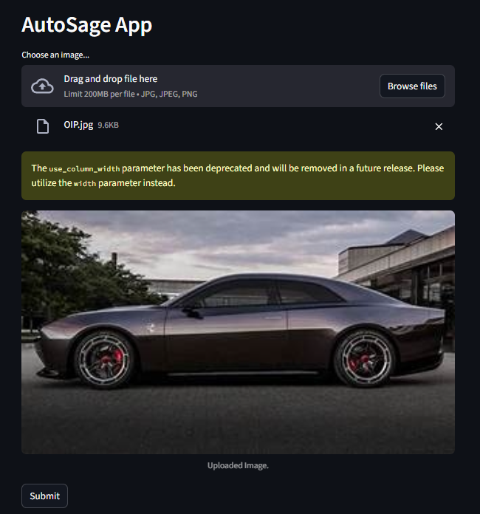

The details about the Vehicle are as follow:
Here's a detailed overview of the vehicle pictured, the Dodge Charger Daytona SRT Concept:
Brand: Dodge Model: Charger Daytona SRT Concept Launch year: The concept vehicle was first unveiled in August 2022. The production version, heavily influenced by this concept, is anticipated to launch in late 2024 as a 2025 model year vehicle.
Key Features:
- Engine Capacity/Type: This is an all-electric muscle car concept. It is powered by Dodge's new 800V "Banshee" propulsion system, representing the brand's highest performance tier for electric vehicles. It's a 2-door performance coupe, designed to be a direct successor to the current generation of HEMI-powered muscle cars.
- Special Features:
  - "Fratzonic" Chambered Exhaust System: An industry-first technology, this unique feature uses an amplifier and tuning chamber to create an artificial, yet authentic-sounding, exhaust note that reaches up to 126 dB, replicating the visceral experience of a gas-powered muscle car.
  - R-Wing Aerodynamic Pass-Through: A distinctive front aerodynamic feature integrated into the front fascia that allows air to pass through the front opening and over the hood, improving downforce and enhancing the car's aggressive stance while paying homage to the original Charger Daytona.
  - eRupt Multi-Speed Transmission with PowerShot: The concept features a multi-speed transmission with electro-mechanical shifting, designed to provide distinct shift points and a more engaging driving experience, unlike typical single-speed EVs. The "PowerShot" feature provides a temporary boost in horsepower for enhanced acceleration.
Mileage: As an all-electric vehicle, mileage is measured in range per charge rather than km/l. While specific figures for the concept were not released, high-performance EVs typically offer an estimated range of 350-550 km on a full charge, depending on driving conditions and battery size.
Average Price in INR: This is a concept car, so there is no official market price. However, if a production version with similar performance and technology were to be launched and imported into India, it would likely fall into the premium performance EV segment. An estimated price range, considering import duties and taxes, could be INR 1 Crore - 1.5 Crore, depending on the trim and battery configuration.
Other Details:
- Maintenance Costs: As an electric vehicle, the production version is expected to have lower routine maintenance costs compared to internal combustion engine vehicles, due to fewer moving parts, no oil changes, spark plug replacements, or fuel filter changes. However, specific costs for specialized EV components would depend on the availability of service networks.
- Additional Benefits: Instantaneous torque delivery typical of EVs, leading to blistering acceleration. Zero tailpipe emissions. The unique blend of muscle car heritage with futuristic EV technology.
- Unique Selling Points (USPs): Its most compelling USP is its audacious attempt to translate the raw, emotional experience of a classic American muscle car into an electric format, particularly through the groundbreaking "Fratzonic" exhaust and the eRupt multi-speed transmission. It aims to deliver not just performance, but also the distinctive character and sound that muscle car enthusiasts cherish.
Approximate Resale Value after 10 years: It is extremely challenging to estimate the resale value for a concept car, especially one anticipating an electric production version. For a hypothetical production model launched today:
- High-performance muscle cars (even ICE ones) from Dodge often hold their value well, especially limited editions.
- However, the long-term resale value of high-performance EVs after 10 years is still an evolving market. Factors like battery degradation, advancements in battery technology, and charging infrastructure could significantly influence it.
- Given these uncertainties, a rough estimate for a premium, performance-oriented EV after 10 years in the Indian market would typically see a depreciation of 60-80% from its original purchase price. This could mean a resale value ranging from INR 20 Lakhs to 60 Lakhs, though this is highly speculative and subject to market evolution and the specific condition and maintenance of the vehicle. For a car that might become a collector's item, this could change.

8. ADVANTAGES & DISADVANTAGES
Advantages
- Fast AI responses (Gemini Flash)
- User-friendly interface
- Cost-effective
- Easy to deploy
- Scalable
Disadvantages
- Requires internet connection
- Dependent on API availability
- API key security concerns
- Limited customization without backend expansion

9. CONCLUSION
AutoSage App demonstrates successful integration of Google Gemini Flash into a real-world AI application. The project highlights how generative AI can be embedded into web applications to improve productivity, automation, and learning.
The system is scalable, efficient, and practical for modern AI-driven solutions.

10. FUTURE SCOPE
- Add conversation history
- User authentication system
- Multi-language support
- Voice input integration
- Deployment on Google Cloud Run
- Database integration
- Mobile app version
- Integration with document upload (PDF summarization)

11. APPENDIX
Source Code
from dotenv import load_dotenv
load_dotenv()
import streamlit as st
import os
import google.generativeai as genai
from PIL import Image
genai.configure(api_key=os.getenv("GOOGLE_API_KEY"))

def get_gemini_response(input_prompt,image):
model=genai.GenerativeModel('gemini-2.5-flash')
response=model.generate_content([input_prompt,image[0]])
return response.text

def input_image_setup(uploaded_file):
if uploaded_file is not None:
bytes_data = uploaded_file.getvalue()

image_parts = [
{
"mime_type": uploaded_file.type,
"data": bytes_data
}
]
return image_parts
else:
raise FileNotFoundError("No file uploaded")

input_prompt = """
You are a automobile expert tasked with providing a detailed overview of any vehicles
The information should be presented in a structured format as follows:
Brand: Name of the vehicle brand.
Model: Specific model of the vehicle.
Launch year: Since when the Vehicle is available in market
Key Features: Describe the engine capacity, type (e.g., scooter, motorcycle, sedan, SUV), and special features(any top 3)
(e.g., ABS, digital display, storage capacity, safety features).
Mileage: Provide the average mileage in km/l (kilometers per liter).
Average Price in INR: Mention the price range of the vehicle model.
Other Details: Include information on maintenance costs, additional benefits, and any unique selling points.
Approximate Resale Value: Estimate the resale value of the vehicle after 10 years in Indian Rupees.
"""

st.set_page_config(page_title='Welcome')
st.header('AutoSage App')

uploaded_file = st.file_uploader("Choose an image...", type=["jpg", "jpeg", "png"])
image = ""
if uploaded_file is not None:
image = Image.open(uploaded_file)
st.image(image, caption="Uploaded Image.", use_column_width=True)

submit = st.button('Submit')

if submit:
image_data = input_image_setup(uploaded_file)
response = get_gemini_response(input_prompt, image_data)
st.header('The details about the Vehicle are as follow:')
st.write(response)

GitHub & Project Demo Link
- GitHub Repository: https://github.com/Dineshlakshmansai/AutoSage-App-Using-Gemini-Flash

